Unit 2 Parent Packet
Don’t forget the Washington Middle School Math Resource Website
https://washingtonmiddleschoolmath.weebly.com/
Standard: 6.RP.1
- I can write a ratio to describe the relationship between two quantities.
- I can write a ratio using three different formats.

Examples:

In this example, the problem is asking for a ratio of moons to circles. The number representing moons should come first in your ratio, because it was first in the problem. There are 15 moons and 5 circles. An acceptable answer in any of the three formats could be 15:5, 15 to 5, or $\frac{15}{5}$. 6th graders may use any format they are comfortable with, however they should know all three formats and recognize them as being ratios.

Misconceptions: Students could make careless errors in listing ratios in an incorrect order, such as 5 to 15 in the above example. Another issue students may have is not recognizing the fraction form as being a ratio format because they spent so much time on fractionsin 5th grade.

Supplementary Material: http://www.purplemath.com/modules/ratio.htm
*The next few links are on a free website but it will ask you to create a login. I have a Google e-mail account and just select the option to login with Google. If you choose to create a profile, you won’t receive too many e-mails from them and it is a great resource that we use weekly to help explain certain topics.
https://learnzillion.com/lessons/304-express-a-ratio-in-the-simplest-form#
https://learnzillion.com/lessons/308-use-ratio-notation-to-express-relationships
https://learnzillion.com/lessons/601

Standard: 6.RP.2
- I can describe a unit rate in words.
- I can write a unit rate in a/b and a:b form.

Examples:
For this standard, students are just describing rates as ratios. An example of a rate would be 30 miles per hour. Rates compare two different things. In this example, we are comparing miles and hours. This is different from ratios we’ve worked with previously such as boys to girls, which both compare genders. We would write this rate as 30/1 or 30:1.

Misconceptions:
Students need to recognize that rates are different from the part to part or part to whole ratios we’ve already discussed but that a rate changes at a constant which makes it a ratio.

Supplementary Materials:
https://learnzillion.com/lessons/839-understand-rates-as-a-type-of-ratio

Standard: 6.RP.3a
- I can use a table to find equivalent ratios.
- I can find missing values in equivalent ratio tables.
- I can plot pairs of values on the coordinate plane.
- I can use tables to reason about equivalent rations.
- I can use a tape diagram to reason about equivalent ratios.
- I can use a double number line to reason about equivalent ratios.

Examples:
This is an extension to what was learned in the first quarter. Students already know what ratios are and how to use them in a table. They are now plotting them on a graph. Input values are your “x” values; output values are your “y” values. To plot a point on a graph, you go left or right to the x value first, then up or down to the y value.
In this example, students are using what they know about ratios to fill in a table. In number 1, students can look at the input and output to determine the relationship. You have 36:37, 69:70, 14:15, and 48:49. For each input value, if you add 1, you have found your output value, so the answer would be 56. In number 2, you have 31:21, 74:64, 94:84, and 95:85. If you subtract 10 from each input value, you have found your output value. The answer here would be 8. *This is a slight preview of pre-algebra/algebra skills students will be moving to.

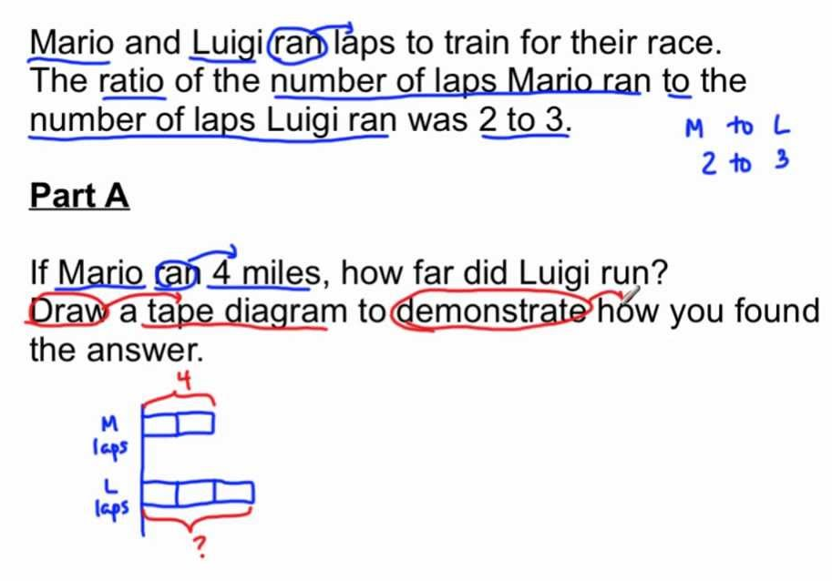
This is an example of using a tape diagram to model problems. Students used tape diagrams as an additional model in 5th grade for many things but especially in their work with fractions. It is basically a rectangular diagram, similar to a tape, that is divided into the number of pieces matching to problem, or in this case the person. Mario’s ratio of 2 laps equaled 4 miles. So if Luigi ran three laps, how many miles did he run? Each lap, or piece of the tape, would equal 2 miles, so Luigi ran 6 miles.

Misconceptions:
Don’t stress over the tape diagrams! They are new and different, but if you are having trouble understanding them, give me a call or send an e-mail and I would be glad to explain them further. They were new for me too. With just a little practice, they will make sense and could easily become a favorite diagram for your student.

Supplementary Material:
https://www.youtube.com/watch?v=c6Pa34wRVEk –video on using tape diagrams to solve ratio problems
https://learnzillion.com/lessons/319 -Finding missing ratio values
https://learnzillion.com/lessons/315 -Equivalent ratios
https://learnzillion.com/lessons/609 -double number line

Standard: 6.RP.3b
- I can solve unit rate problems with unit pricing.
- I can solve unit rate problems using constant speed.
Examples:
This is an example of both a unit pricing problem and a constant speed problem. There are many methods students can use to solve these problems including a table, multiplication/division, number lines, or graphs.
For the first problem, students should easily recognize that 40÷8 is 5 or 8x5=40, which would make your answer $5 per hamburger.
The second problem is a little more difficult. We know that we are comparing Vanessa and Cody, so our ratio would be$\frac{4}{3}$. We know that as a rate, our ratio is going to change at a constant speed, so we are finding an equivalent ratio to$\frac{4}{3}$. The numerator represents Vanessa’s value, so we want our 1 in the numerator in our equivalent ratio. So we know $\frac{4}{3}$ = $\frac{1}{?}$. To change our numerator we must divide 4 by 4 to get 1. So we must perform the same operation to the denominator. Students may leave 3÷4 as $\frac{3}{4}$ so the answer is$\frac{3}{4}$.

Misconceptions:
Students may forget that a fraction is also a division problem, like in our example. $\frac{3}{4}$ is the same thing as 3÷4 so it can be written both ways. In solving problems, students tend to doubt themselves or their abilities. Oftentimes they know how to do the work; it’s just a matter of them realizing they do know how to tackle these problems.

Supplementary Materials:
https://learnzillion.com/lessons/614-solve-rate-problems-using-multiplicative-reasoning
https://learnzillion.com/lessons/613-solve-rate-problems-using-double-number-lines
https://learnzillion.com/lessons/612-solve-for-missing-values-in-rate-problems-using-a-table
https://learnzillion.com/lessons/615-graphing-rate-problems-using-a-table
These are all different ways to solve rate problems using different models.
http://www.commoncoresheets.com/Math/Ratios/Rate%20Language/English/1.pdf -Practice problems

Standard: 6.RP.3c
- I understand that percent means “per hundred”
- I can find a percent of a quantity as a rate.
Examples:
Percents are “per hundred” or out of 100. This means 50% could also be written as $\frac{50}{100}$ or 0.50 (zero and fifty hundreths). Students can use their knowledge of equivalent ratios and equivalent fractions to help them find the percent in ratio problems.

So let’s say 50% of the cars in the parking lot are red. This can be written as a ratio in the three different forms: 50 to 100, 50:100, or $\frac{50}{100}$. Using the fraction, we can reduce that to $\frac{5}{10}$, and then again to $\frac{1}{2}$.

Adding to the above problem: 50% of the cars in the parking lot are red. There are 300 cars in the parking lot. How many are red?
We know the ratio is $\frac{50}{100}$. We know there are 300 cars in the parking lot, so 300 will be our denominator because that is the total number of cars. Just like our rate problems, we can set $\frac{50}{100}$ = $\frac{?}{300}$.
To change our denominator, we would multiply 100 by 3. We need to also multiply 50 by 3 so we create and equivalent ratio. 50x3=150, so our answer is 150.

There are many different methods to solve this problem, this is just the one I chose as it is probably the one they will see in future classes.

Misconceptions:
Students haven’t had much practice with percents, especially figuring out what they are from fractions or decimals. Therefore, it may be difficult for students to realize that 50% doesn’t mean 50. It depends on the whole.

There are also many different methods students will learn. It is important they are familiar with these methods, but need to find one they like best and master it to help eliminate confusion.

Supplementary Materials:
https://learnzillion.com/lessons/593-define-percents-as-ratios -Understanding percents as ratios
https://learnzillion.com/lessons/596-find-the-part-when-the-percent-and-total-are-known Solving when the part is unknown
https://learnzillion.com/lessons/597-find-the-total-when-the-percent-and-part-are-known Solving when the whole is unknown
https://learnzillion.com/lessons/598-solve-percent-problems-using-a-ratio-table Solving using a table

Standard: 6.RP.3d
- I can use ratio reasoning to convert measurement units.

Examples:

A jar holds 112 gallons of juice. How many quarts of juice is this?

This question was pulled from our TLI website. This is the company we use to provide quarterly data on our students performance. Students learned how to convert between measurements at the end of the year in 5th grade. We used a format that works for any situation, in any grade level. We called it the “big plus sign” First, you draw a big plus sign.

Then, you put the value you know from the problem in the top left box. In this problem, that will be 112 gallons. You also ALWAYS put a 1 in the box underneath this value.
112 gallons
1

Next, you fill in your conversion in the last two boxes. You want the same unit to be in the box diagonal to your “what you know” box. So, in the bottom right box, we want gallons because that is diagonal to our what we know, and our what we know is in gallons. In the remaining box, the top right, we want the unit that we want our answer in, which is quarts. Students will be provided with a reference sheet that has the conversion 1 gallon=4 quarts.

112 gallons 4 quarts
- 1 gallon

The unit “gallons” cancels out by being opposite each other, leaving your answer in quarts. Now all the student does in multiply straight across, getting a fractional answer.

112 gallons 4 quarts 448
1 1 gallon 1 448 quarts

Students should be able to recognize in a fraction, any number over 1 is that number. If you need more examples on this conversion format, please let me know.

Misconceptions:
Students can struggle with knowing where to put what number and unit with confidence. This is something we will practice, practice, practice and it will eventually become routine for them.

Supplementary Material:
https://learnzillion.com/lessons/322 -centimeters to inches
https://learnzillion.com/lessons/323-convert-between-meters-and-feet-using-ratios -Meters to feet
https://learnzillion.com/lessons/325-convert-between-pounds-and-kilograms-using-ratios -pounds to kilograms

