5th Grade Unit 4 Parent Packet

Don’t forget the Washington Middle School Math Resource Website
https://washingtonmiddleschoolmath.weebly.com/

Standards 5.NF.B.4,5.NF.6
- I can multiply fractions by fractions, fractions by whole numbers, fractions by mixed numbers and mixed numbers by mixed numbers.
- I can solve real world problems involving the multiplication of fractions, whole numbers, and mixed numbers.

How to multiply fractions by fractions:

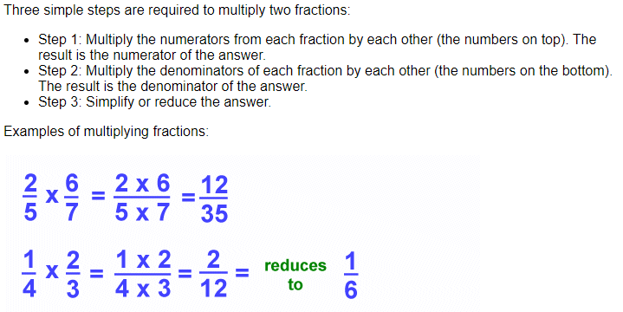

How to multiply fractions by mixed numbers:
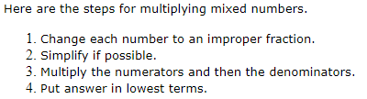
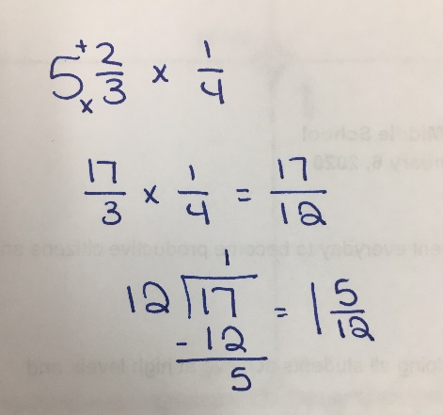

How to multiply mixed numbers by mixed numbers:

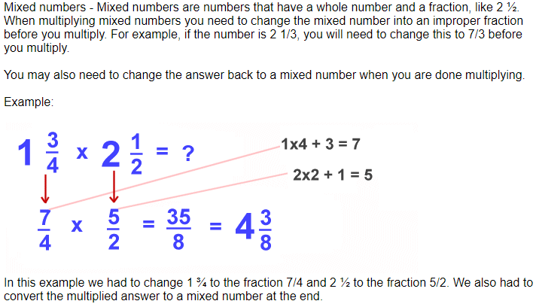

How to multiply fractions by whole numbers:

Step 1: 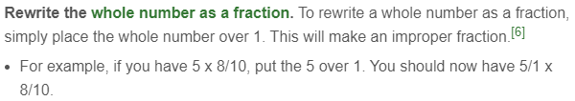
Step 2:
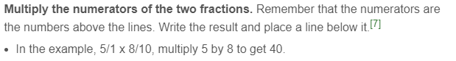
Step 3:
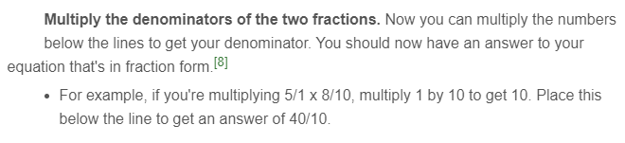
Step 4:
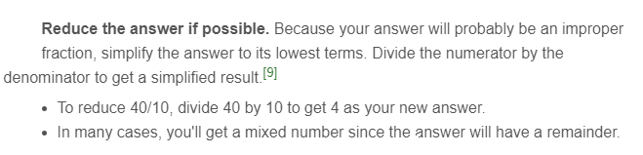
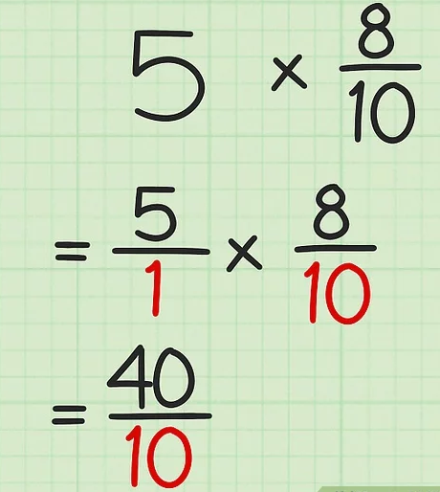

How to multiply a mixed number by a whole number: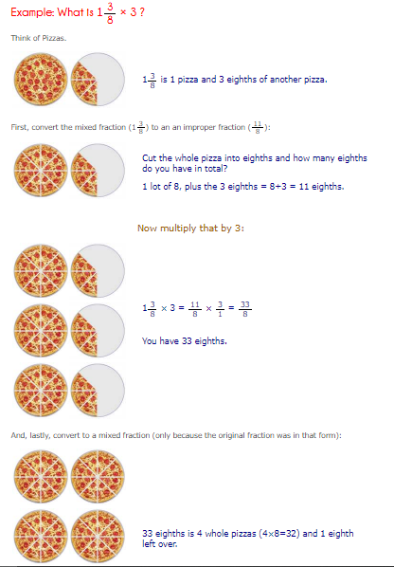
Extra Practice:
https://www.math-aids.com/cgi/pdf_viewer_3.cgi?script_name=fractions_multiply.pl&difficult=0&probs=10&language=0&memo=&answer=1&x=97&y=15

https://www.math-aids.com/cgi/pdf_viewer_3.cgi?script_name=multiplying_mixed_numbers.pl&difficult=0&probs=10&language=0&memo=&answer=1&x=73&y=40

https://www.math-aids.com/cgi/pdf_viewer_3.cgi?script_name=fractions_multiply_whole.pl&difficult=0&format=0&probs=10&language=0&memo=&answer=1&x=103&y=25

Standard 5.NF.B.3
- I can interpret a fraction as division.

Examples:
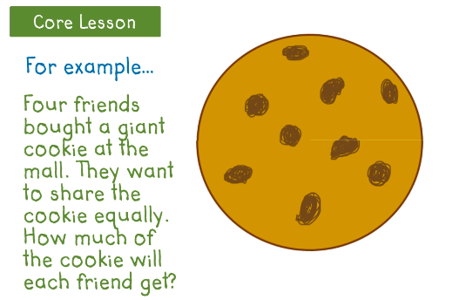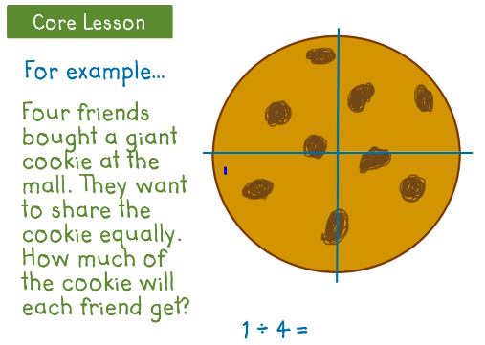
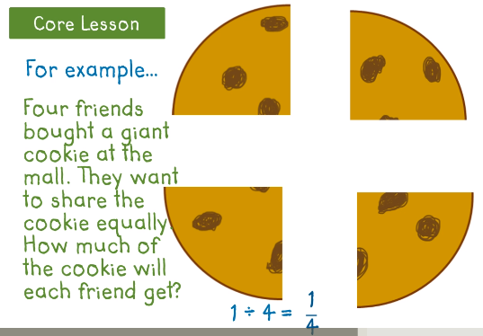

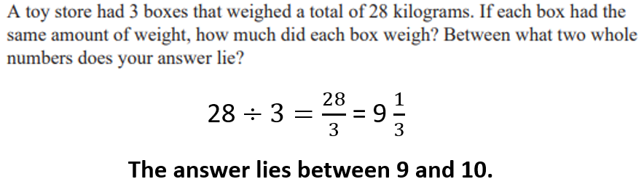
Extra Practice:
https://www.commoncoresheets.com/Math/Fractions/Division%20as%20Fraction%20-%20Word/English/7.pdf

Review Skills

Comparing Fractions
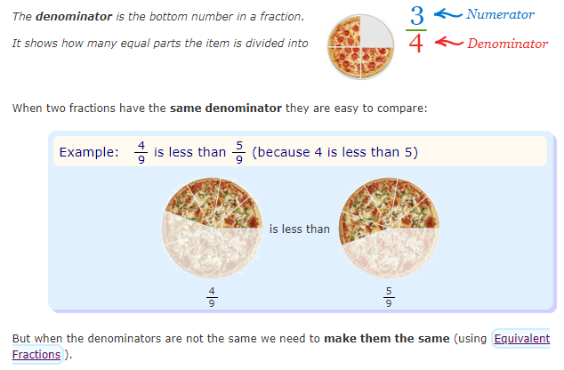

Ordering fractions
Steps:
1. Find the common denominator
2. Find equivalent fractions
3. Compare the numerators
4. Put the fractions in order as directed
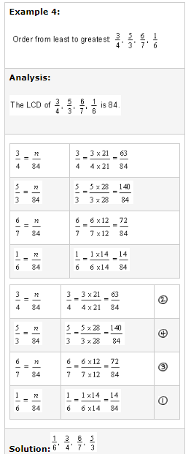

Placing fractions on a number line
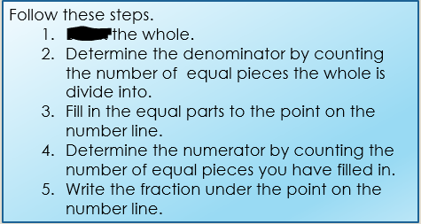

Find

Place 6/8 on the number line below.
