5th Grade Unit 3 Parent Packet
Please remember to check the WMS Math Website for videos relating to this unit: https://washingtonmiddleschoolmath.weebly.com/
Standard:
5.NF.A.1 I can efficiently, accurately, and with some degree of flexibility, add and subtract fractions with unlike denominators (including mixed numbers) using equivalent fractions and common denominators

5.NF.A.2 I can solve word problems involving addition and subtraction of fractions referring to the same whole, including cases of unlike denominators
result 2/5 + 1/2 = 3/7, by observing that 3/7 < 1/2.

For these standards, students are expected to solve addition and subtraction problems with unlike denominators. Students will focus on finding equivalent fractions and using these equivalent fractions to create common denominators to be able to solve the problems.

Even though this unit only covers 2 standards, there is a lot of information that is has to be covered for students to be able to add and subtract fractions with unlike denominators.

How to add fractions with like denominators

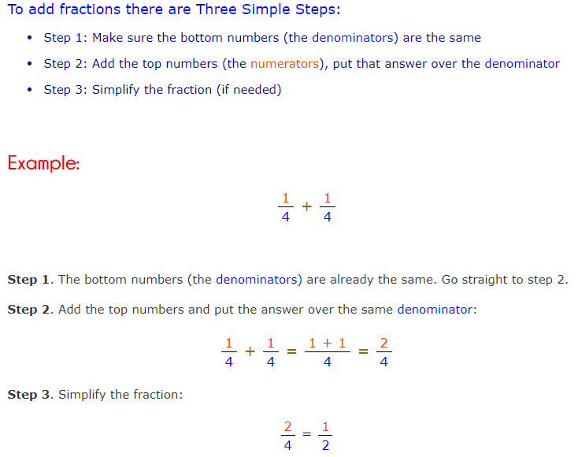

Extra Resources:
https://www.mathgoodies.com/lessons/unit16/adding-fractions-with-like-denominators
https://www.k5learning.com/free-math-worksheets/fourth-grade-4/fractions/adding-fractions-like-denominators
How to Subtract Fractions with like Denominators

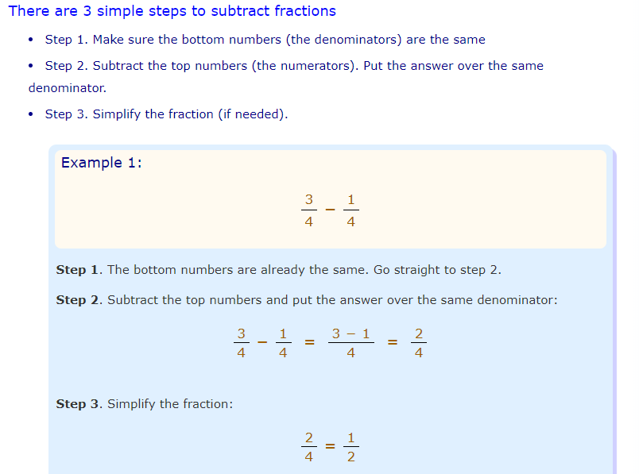
Extra Resources:
https://www.mathgoodies.com/lessons/unit16/subtracting-fractions
https://www.k5learning.com/free-math-worksheets/fourth-grade-4/fractions/subtracting-fractions-like-denominators
How to Simplify Fractions
A fraction is in simplest form when the top and bottom cannot be any smaller, while still being whole numbers. To simplify a fraction: divide the top and bottom by the greatest common factor that will divide both numbers exactly (they must stay whole numbers). 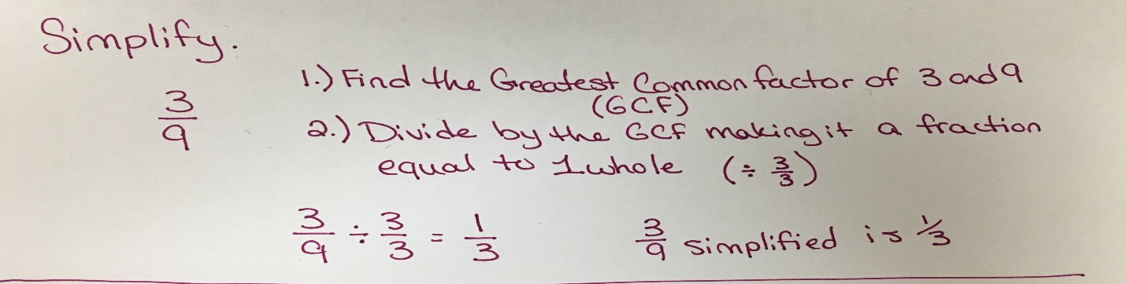
Extra Resources:
https://www.mathsisfun.com/simplifying-fractions.html
http://www.math-aids.com/cgi/pdf_viewer_3.cgi?script_name=reduce_fractions.pl&difficult=1&probs=30&language=0&memo=&answer=1&x=163&y=24

How to Change Mixed Numbers to Improper Fractions
A Mixed Fraction is a whole number and a proper fraction combined. An Improper Fraction has a top number larger than (or equal to) the bottom number.
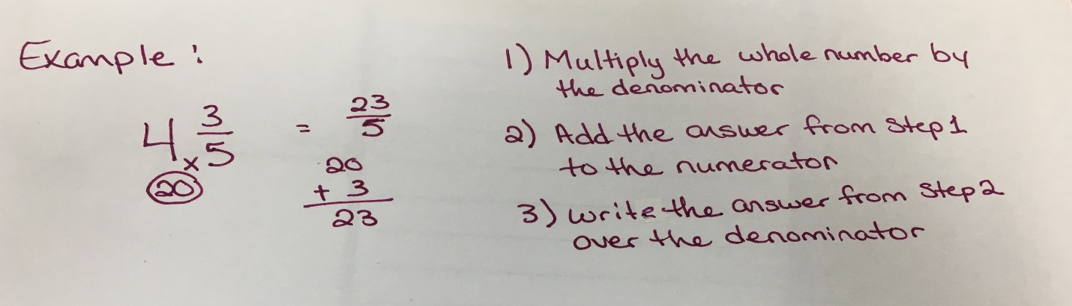
Extra Resources:
https://www.infoplease.com/math-science/mathematics/numbers-formulas/mixed-numbers-and-improper-fractions
https://www.commoncoresheets.com/Math/Fractions/Mixed%20Number%20to%20Improper/English/4.pdf
How to Change Improper Fractions to Mixed Numbers
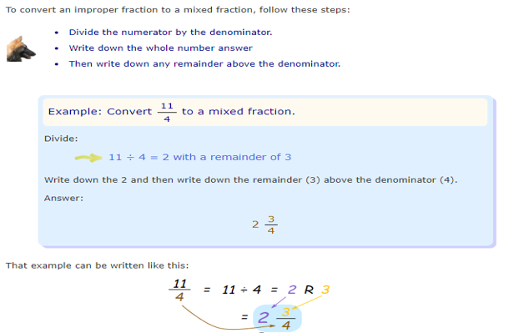
Extra Resources:
https://www.mathsisfun.com/improper-fractions.html#:~:targetText=To%20convert%20an%20improper%20fraction,any%20remainder%20above%20the%20denominator.
http://www.math-aids.com/cgi/pdf_viewer_3.cgi?script_name=fractions_improper.pl&difficult=1&language=0&memo=&answer=1&x=138&y=19

How to Find Equivalent Fractions
To find equivalent fractions, multiply or divide the numerator AND denominator by the same nonzero whole number. For example: The fraction 4/4 is equal to one whole. The numerator is 4 and the denominator is 4 so you can multiply or divide by the fraction 4/4 and get and equivalent fraction. This can be seen in the examples on the next page.
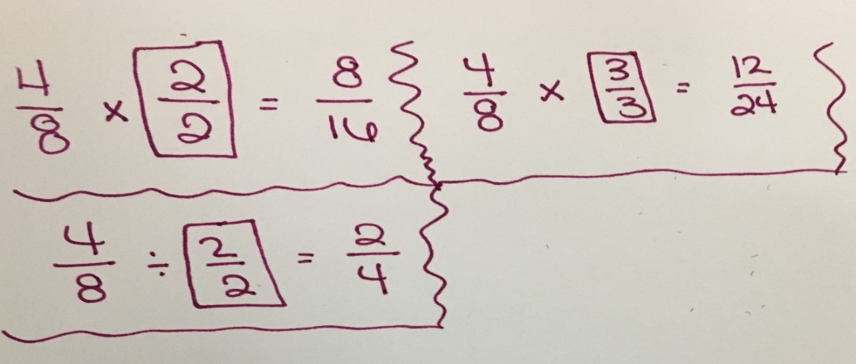
Extra Resources:
https://www.mathsisfun.com/equivalent_fractions.html
https://www.commoncoresheets.com/Math/Fractions/Equivalent%20Fractions%20(Missing%20Number)/English/3.pdf

How to Add Mixed Numbers with Common Denominators
Follow the steps below to add mix numbers with common denominators.
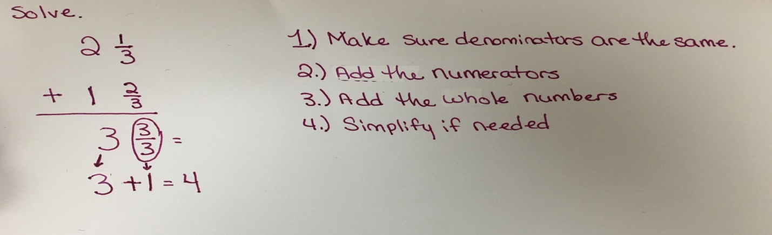
Extra Resources:
https://www.k5learning.com/free-math-worksheets/fourth-grade-4/fractions/adding-mixed-numbers-like-denominators

How to Subtract Mixed Numbers with Common Denominators
Follow the steps below to subtract mixed numbers with common denominators.
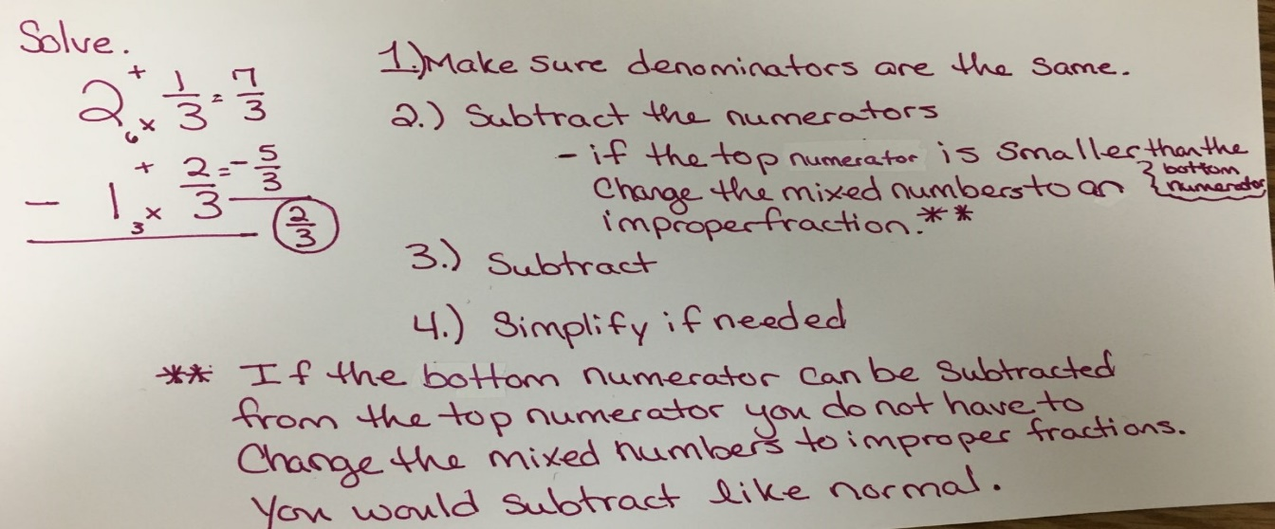
More examples are on the next page.
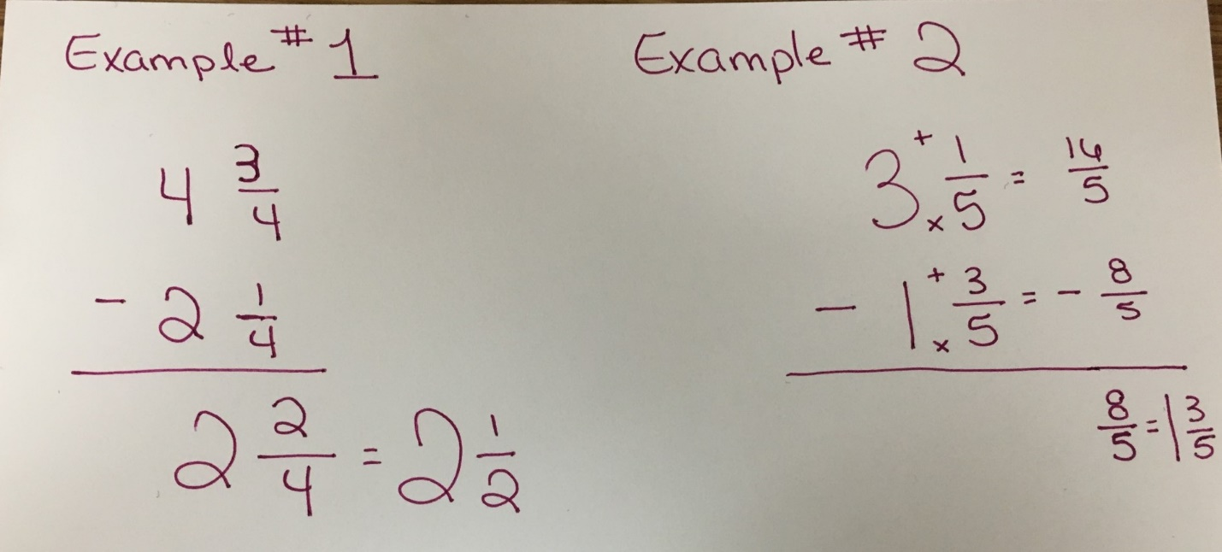

Extra Resources:
https://www.k5learning.com/free-math-worksheets/fourth-grade-4/fractions/subtracting-mixed-numbers-like-denominators

How to Add fractions with Unlike Denominators
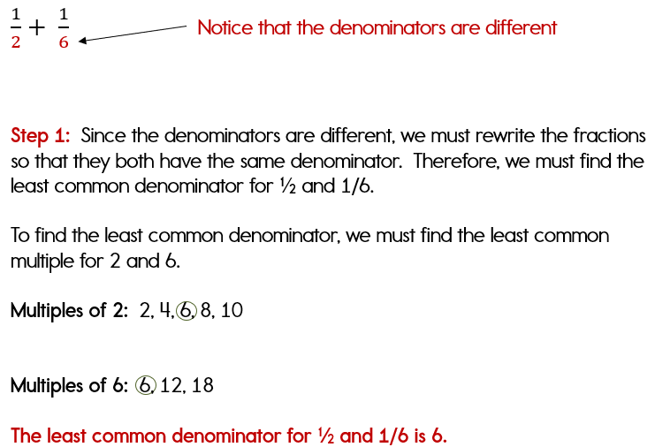
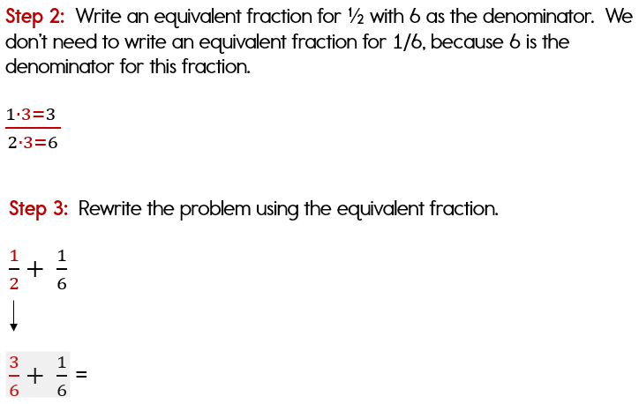
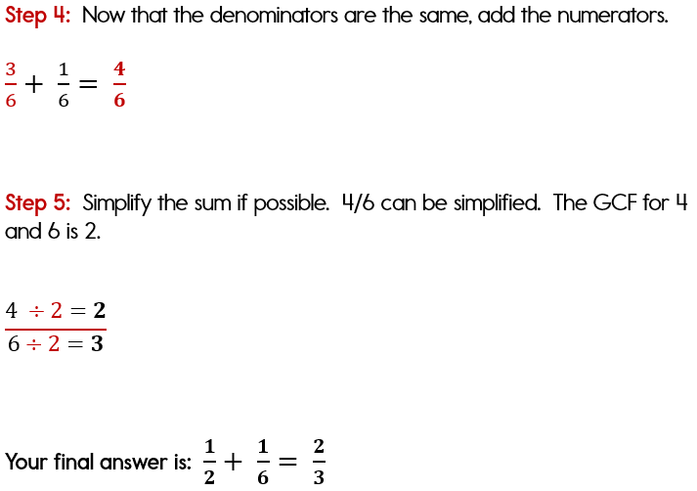
Extra Resources:
http://www.math-aids.com/Fractions/Adding_Fractions.html

How to Subtract Fractions with Unlike Denominators
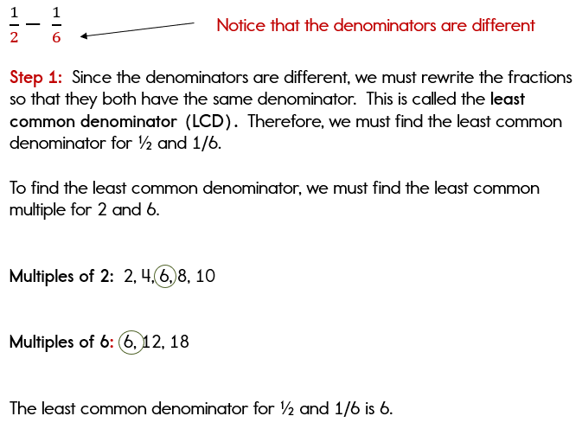
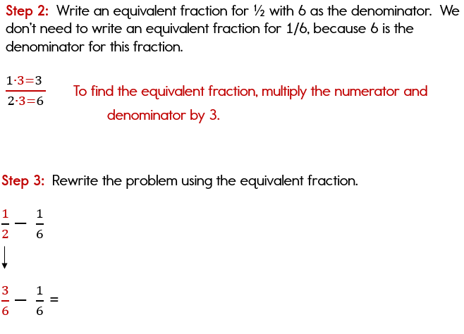
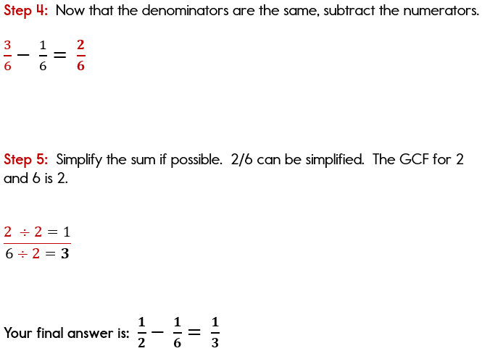
Extra Resources:
http://www.math-aids.com/Fractions/
How to Add Mixed Numbers with Unlike Denominators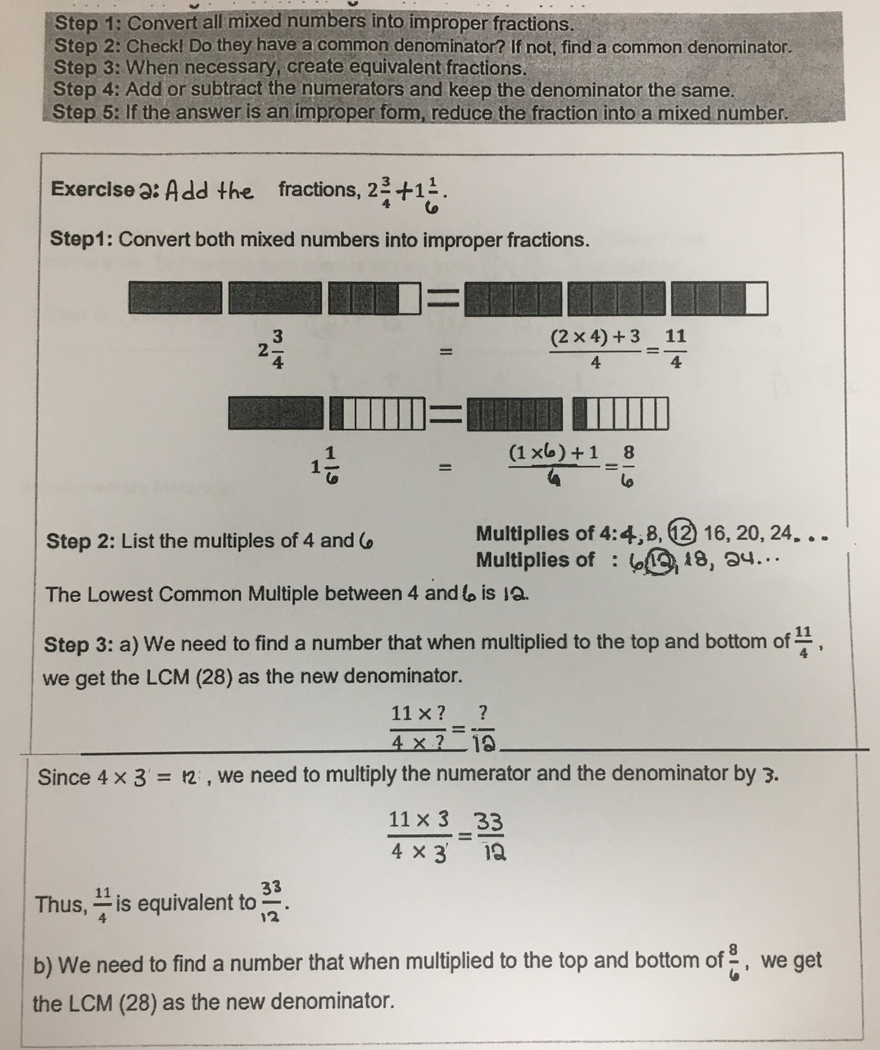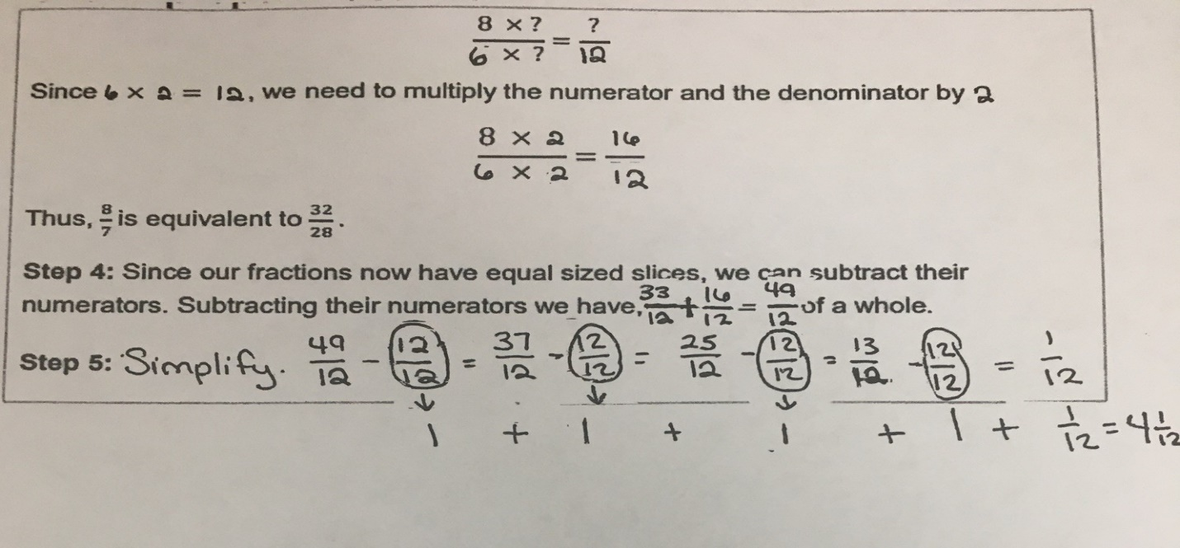
Extra Resources:
http://www.math-aids.com/Fractions/Adding_Mixed_Numbers.html

How to Subtract Mixed Numbers with Unlike Denominators
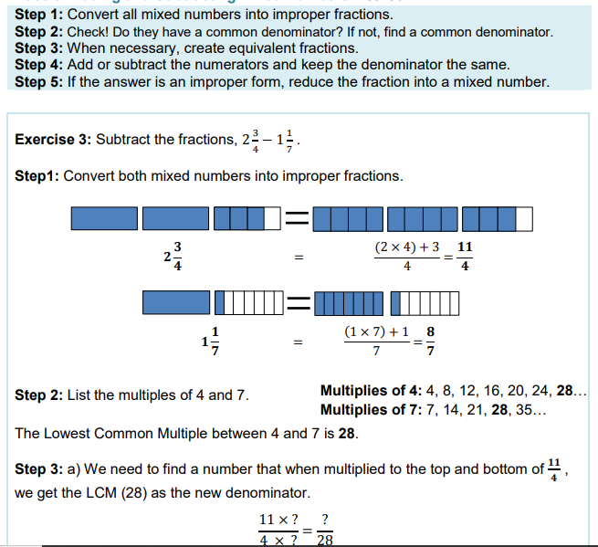
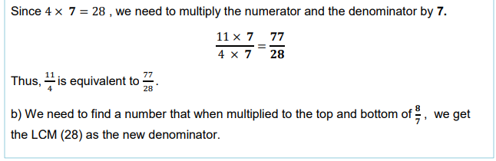
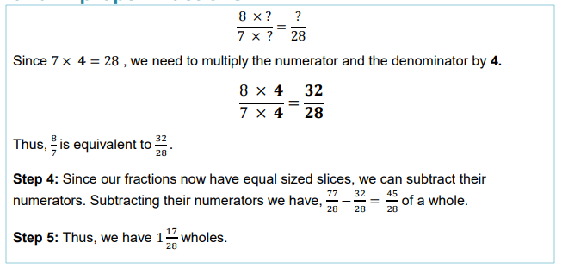
Extra Resources:
http://www.math-aids.com/Fractions/Subtracting_Mixed_Numbers.html

