Unit 2 Parent Packet
Don’t forget the Washington Middle School Math Resource Website
https://washingtonmiddleschoolmath.weebly.com/

Standard 5.OA.A.1
- I can use grouping symbols including parentheses, brackets, or braces in numerical expressions, and evaluate expressions with these symbols
Examples:
At the beginning of this unit students will review the zero, associative, commutative, and distributive properties.
Associative property Commutative property
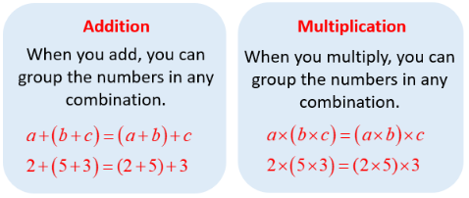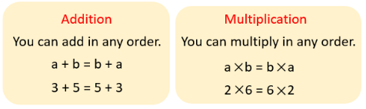
Distributive Property
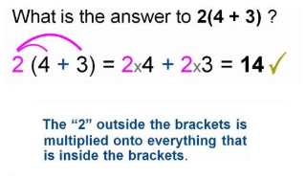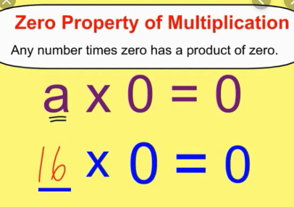

During this time students will also begin solving expressions and equations. There are several ways that help us to remember the order we solve expressions and equations, our students will most likely see GEMA. (An example is shown below) 5th grade students will not be doing negative numbers, but this gives you a good idea of how this helps the students solve the problem.
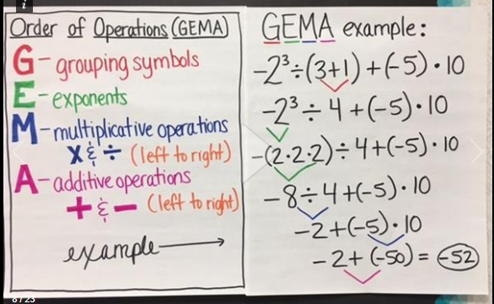
Solving an expression Solving an equation
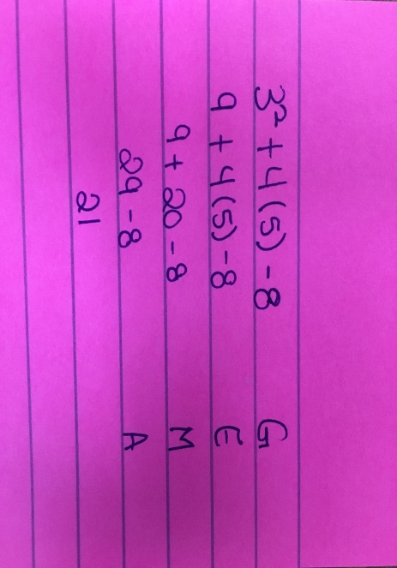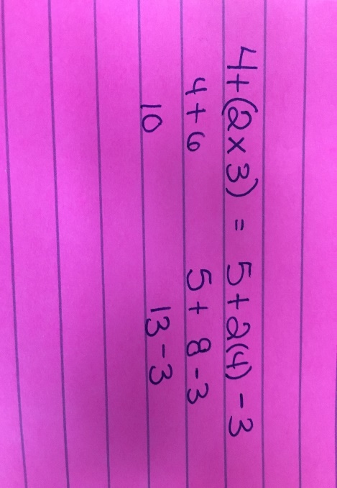
Common Misconceptions:
A common misconception that students have is that they can only multiply before division or add before subtraction. This is not the case. When solving an expression or equation students should multiply or divide from left to right with which ever operation comes first. This is the same with addition and subtraction. Another common misconception that students have is that an equation and an expression is the same thing. This is not the case. An expression is a mathematical phrase that contains numbers and/or variables (letters) and use mathematical operations. Ex: Solve this expression. 2x + 3(6) where x=5 An equation is a mathematical statement where two mathematical expressions are equivalent. Ex. 5+6=11 or 5+6 = 3+8
Supplementary Material
Identifying properties: https://www.mathworksheetsland.com/3/grade3-5c-5pack.pdf (worksheet)
https://www.youtube.com/watch?v=jG9E2pev3bQ (video)
Solving Expressions: https://www.education.com/download/worksheet/97749/algebra-expressions.pdf (worksheet)
https://www.khanacademy.org/math/algebra/x2f8bb11595b61c86:foundation-algebra/x2f8bb11595b61c86:combine-like-terms/v/combining-like-terms-and-the-distributive-property (video)
Solving Equations: http://www.accessmaths.co.uk/uploads/4/4/2/3/44232537/solving_equations_unknown_both_sides_gsb_worksheet.pdf (worksheet)
https://www.khanacademy.org/math/algebra-home/alg-basic-eq-ineq/alg-solving-equations/v/representing-a-relationship-with-a-simple-equation?modal=1 (video)

Standard 5.OA.A.2
- I can write simple expressions that record calculations with numbers, and interpret numerical expressions without evaluating them
Examples:
For this standard students are learning how to write a numerical expression without evaluating it.

Problem: 4 is subtracted from three-fifths of k
Answer: (3/5 x K)- 4

Problem: Julie has 10 pencils. Julie gives Krystina 5 pencils. Marsha has 8 times the amount of pencils that Julie has after she gives 5 away.
Answer: 10- 5 x 8

Common Misconceptions:
A common misconception that students have is the order in which they should be written. Students have to make sure that they pay attention what the mathematical phrase is asking them to do, not just write it in the order it says it.

Example: 4 is subtracted from three-fifths of k
Wrong Answer: 4- 3/5 x k
Correct Answer: (3/5 x K)- 4

Supplementary Materials:
http://www.math-aids.com/cgi/pdf_viewer_2.cgi?script_name=pre-algebra_translate.pl&hard=1&language=0&memo=&answer=1&x=37&y=19 (worksheet)
https://www.youtube.com/watch?v=KmuWR_LriQU (Video)

Standard 5.NBT.B.5
- I can multiply multi-digit whole numbers using a standard algorithm
Example:
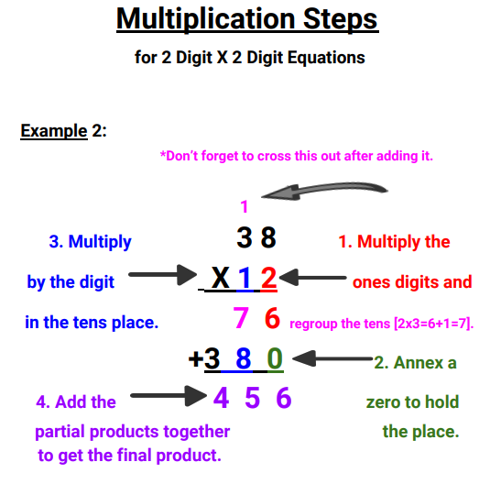
Common Misconceptions:
A common misconception that students make with this skill is that they line up the numbers incorrectly. When multiplying using the standard algorithm students should line all numbers up to the right.
Example: 345 x 12
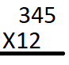
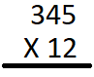
Wrong way: Right way:

Supplementary material:
https://www.k5learning.com/worksheets/math/grade-4-multiply-columns-2-digit-3-digit-a.pdf (worksheet)
https://www.khanacademy.org/math/arithmetic/arith-review-multiply-divide/arith-review-multi-digit-mult/v/multiplication-6-multiple-digit-numbers (video)

Standard 5.NBT.B.6
- I can find whole-number quotients of whole numbers with up to four-digit dividends and two-digit divisors.
Example:
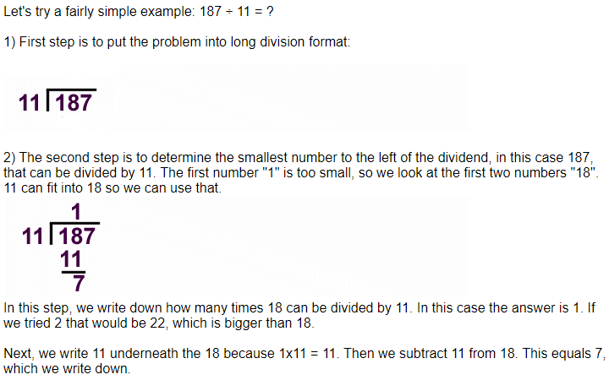
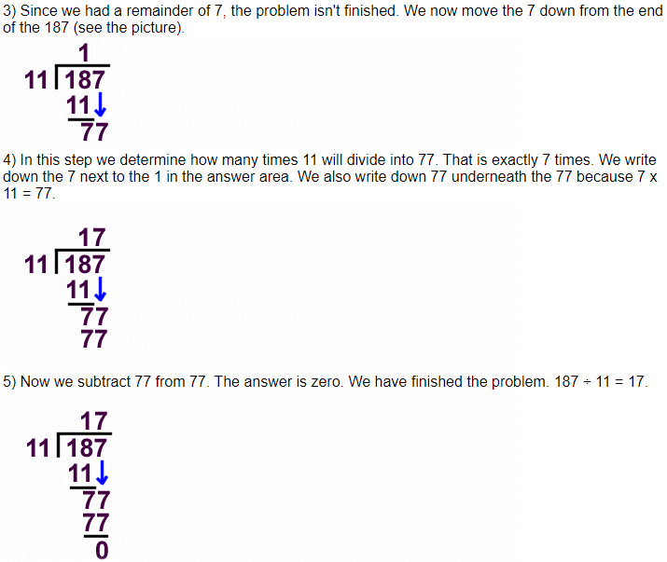
Common Misconceptions:
A common misconception that students make with the standard algorithm of division is that they line up the answer over the wrong place value.
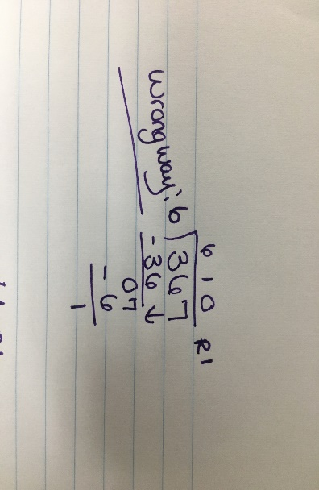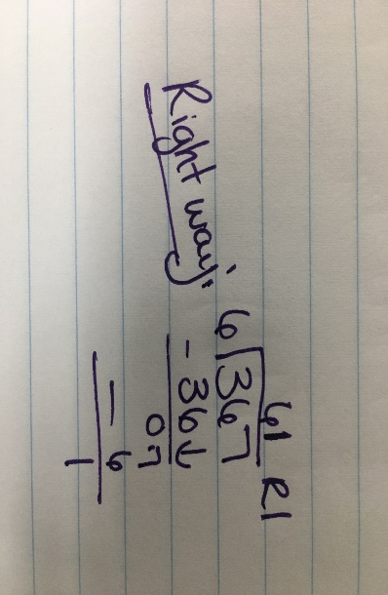
Supplementary Material:
http://www.math-aids.com/cgi/pdf_viewer_2.cgi?script_name=div_short.pl&nqdigit=5&D_2=1&D_3=1&D_4=1&D_5=1&D_6=1&D_7=1&D_8=1&D_9=1&remainder=1&ans_remainder=1&probs=24&language=0&memo=&answer=1&x=170&y=30 (worksheet)
https://www.khanacademy.org/math/arithmetic-home/multiply-divide/mult-digit-div-2/v/division-2 (video)
https://www.khanacademy.org/math/arithmetic/arith-review-multiply-divide/arith-review-multi-digit-div/v/long-division-without-remainder (video)
Standard 5.NBT.B.7
- I can multiply and divide decimals to the hundredths place
Multiplying Decimals:
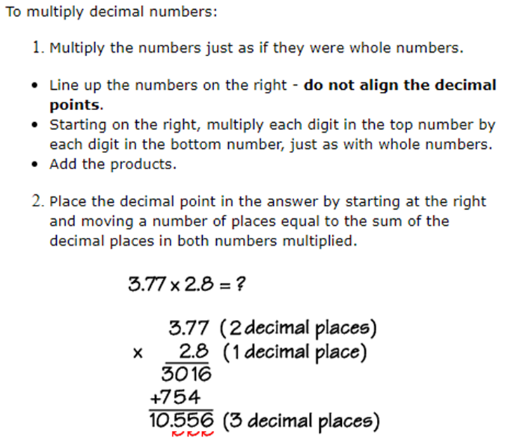
Misconceptions:
Students often line up the place values or put the decimal in the wrong place.
Supplementary Material:
https://www.youtube.com/watch?v=STyoP3rCmb0 (video)
https://www.math-drills.com/search.php?s=Multiplying+decimals&page=1&sort=weekly (Worksheet)

Dividing Decimals

Examples:
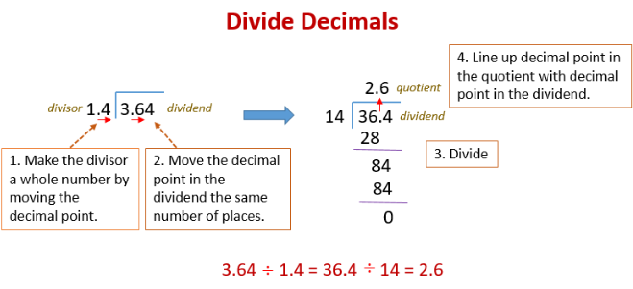
Misconceptions:

Students often forget to put the decimal point in the answer or they put in the wrong place

Supplementary materials:
https://www.khanacademy.org/math/arithmetic/arith-decimals/arith-review-dividing-decimals/v/long-division-with-decimals (video)
https://www.k5learning.com/worksheets/math/grade-5-long-division-decimals-a.pdf (worksheet)

